Title or Task: | Around The World in 80 Clicks
Description: | Major Task
Files Required | Camera, Power Point, Photoshop
Suitable for Classes: | Multimedia / Digital Media or Design
Area: | Technology & Enterprise
Teacher: | Mr Peter Faulks
Marks: | Worth: 20% | Weighting: 15
Date Due: | Late penalty 5 marks plus 2 marks per day thereafter
Task Brief: | Power Point presentation
Outcomes: | Investigation : Devising : Producing : Evaluating

Items highlighted in yellow are tasks for you to complete
Task
4
Items in Purple are help tips
UNIT: Multimedia
TASK 4: Around The World in 80 Clicks (100 marks)

Explanation Task Brief Work as an individual?

Students take themselves on a tour of the world visiting at least four (4) continents and six (6) countries. Providing detailed information about the country or city visited.

Take several photographs of yourself in poses to suit your travels, you MUST be involved in an action shot for something that relates to the country or city (You MAY NOT just take a selfie type shot in front of a building or scene!). Create an animated power point of an around the world tour.

This should be an interactive presentation describing a “virtual world trip”.

You will be required to:

- Create a title screen describing the “trip”, your expected audience,

- Create a Table of Contents, (TOC) with slide navigation instructions and a Help page.

- The slide show must include a picture or map of the world with flying links to each destination and hyperlinks to countries

- Visit at least 4 continents (Note continents start and end with the same letter i.e. EUROPE) and at least 6 places at least one from each continent.

- A minimum of 6 images of famous places from around the world onto which your own digital image has been layered, (Camera is with Teacher) (See samples below).

- In each place visited you must include an action shot of yourself involved in some activity (i.e. skiing down the slopes in Switzerland or Riding a roller coaster at Disney World in the USA)

- Hyperlinks to each place and page

- A paragraph describing each place and give details of currency, language, climate and culture and other (places of interest).

- A paragraph on people, history or background.

- Optional audio/movie files enhancing the presentation

- A conclusion screen with acknowledgements (bibliography) and list of hardware and software used and any other notes.

You need to provide:

- Journal (see below) (lesson by lesson thoughts) - Keep a lesson by lesson journal in which you discuss
  - technical & personal skills,
  - problems and solutions,
  - successes

- Final evaluation (See Evaluation Sheet below – Self Evaluation) (articulates what you have learnt – both personal development & technical skills)

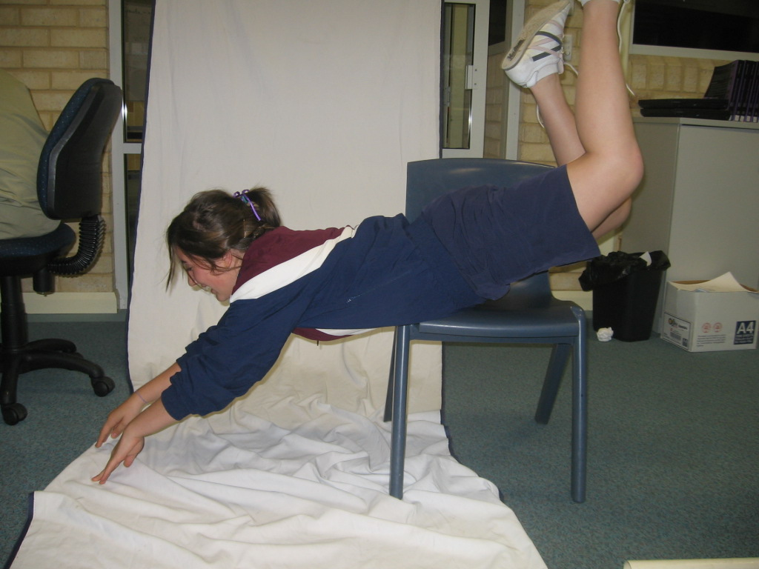
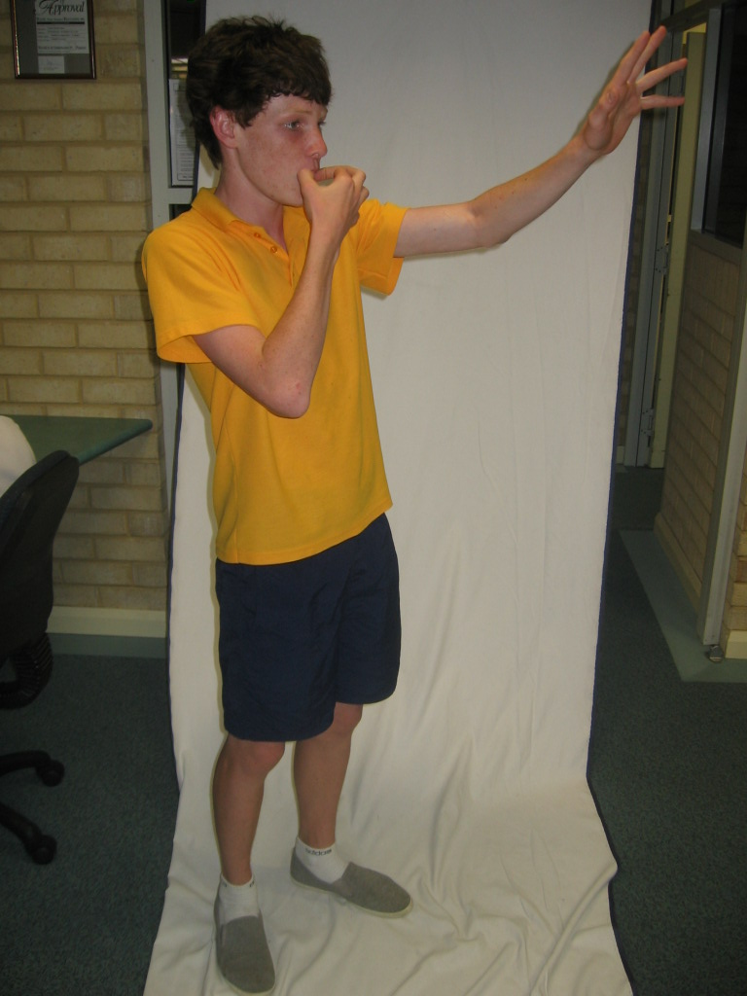
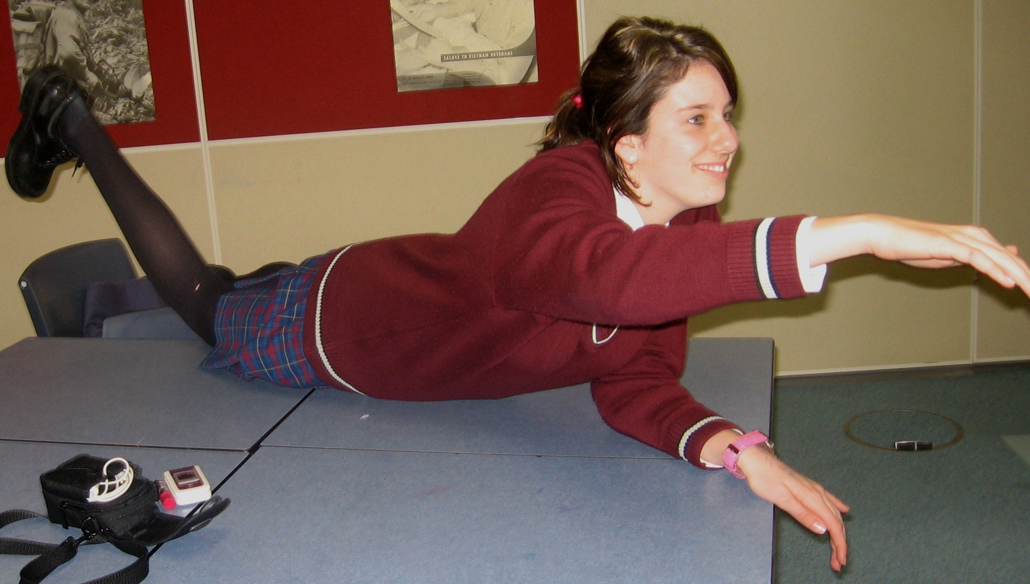

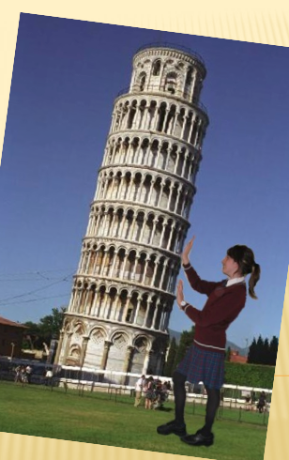

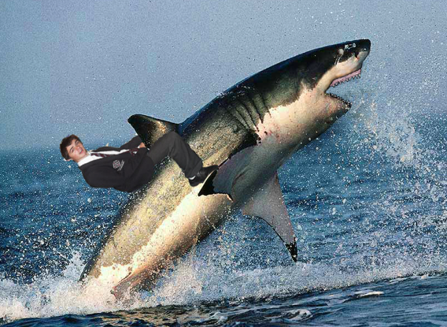

What you need to do:
CREATION OF INFORMATION:
- Chooses appropriate images to convey information about a location
- Selects key information to share as caption for image
- Selects and uses techniques and information to produce product for peers
- Designs a user-friendly layout that conveys information in the best possible way

TECHNOLOGY PROCESS

INVESTIGATING
- Examines a range of electronic or pamphlet resources to get information about world places

DEVISING:
- Provide evidence that you have planned the journey. e.g.: Storyboard, Labels, URLs, Inspiration Concept Maps

PRODUCING:
- Develop a time plan to manage the project. Minimum of 8 places per 4 weeks; 6 places per 3 weeks.

EVALUATING: Using a Diary or Journal to:
- Students keep a record of their thoughts, successes, problems and solutions, modifications, emotions, new aims, new skills (Journal every lesson or self evaluation sheet at end)
- Peer evaluation to look specifically at the quality of information, interest, design and imaging skills.

In class lessons:
- Using Power Point
- Hyperlinks in Power Point Power Point:
- Hidden Links in Power Point

Useful links
Countries:
http://dir.yahoo.com/Regional/Countries/

Climate
http://www.worldclimate.com/

Currency
http://www.rubicon.com/passport/currency/currency.html

Currency Converter
http://www.xe.com/ucc/

Language
http://babel.uoregon.edu/yamada/guides.html

World Religions
http://www.religion-online.org/

Notes Page
Complete the following

Continent visited | Country visited | Climate | Currency | Language and Religion | Attractions

Using Software & Skills: -
Power Point – Image Manipulation – Hyper-linking – Audio - Movies to create a world tour, animated introductory page, TOC and help page.

List websites visited

Site Title or Name | URL address
 | www.
 | http;//

Recording Technical Information:

Name of graphic used | Media type | Format | Size (Kb) | Source (bibliography) | Equipment used | Software used with file
Eg: myphoto | Digital photo | .jpg | 370 Kb | Taken by me | Digital camera | Photoshop
Eg: fuji | Web image | .jpg | 22.8 Kb | www.japantourist.com | Network Connection | Internet Explorer, Photoshop

A table showing all files incorporated into your design, their formats (eg: jpg, .wav, .mov) and file sizes (in Kb) Put files into your folders [Text] [Graphics] etc.

Imaging Skills to look for:
- Scanning, digital photography, resolution, copy/paste, cropping for design style, cloning for enhancement of image, special effects (art strokes, blurs, warp, painted additions), layers, filters/masks.

INFORMATION
Level | The creation of information
Level 4 | Selects and uses a range of techniques when transforming information and creating information products
Level 5 | Selects and uses recognised procedures, conventions and languages to process information and create information products.
Level 6 | Manipulates, transforms and creates information to achieve particular effects and meanings.

STUDENT NAME ________________________

Marking Grid

Topic Around The World | Mark | Your Mark
Continents at least 4 Countries at least 6  World map with animations  TOC and navigation Help Page, Own Photo used | 10
Title Page & Description of Tour Articulates the purpose, key elements, suitable audience on Title screen | 10
Selects and uses a range of techniques when transforming information and creating information products (Quality of Hyperlinks plus sound and animation) | 10
Selects and uses recognised procedures, conventions and languages to process information and create information products. Overall quality. | 10
Appropriate information about the country Currency, Population, Area etc. | 10
Determines the appropriateness of IT; considers communities and environments. In depth additional information. | 10
Quality of Photos & Graphics, Manipulates, transforms and creates information to achieve particular effects and meanings. | 10
Evaluation Assesses the effectiveness of own designs, products, systems, processes, services and environments in relation to design requirements; considers social and environmental criteria. | 10
Overall Quality Completes a functioning PPT presentation. Sensible text & some modified images | 10
Journal Used and Recording Technical Information  Submitted on time. | 10
TOTAL | 100

Teacher Comment:

Journal
For: (Note Replace text with your notes)

Day/ Date | Successes | Problems | Solutions | Goal for next time
1 | Today I enjoyed setting up the power point | We copied the files so that the web pages did not work, as the links did not enable the computer to find the source. | Although we did not complete it, we still developed an understanding as to how it all worked. | Introduction to task assessment.
2
3
4
5
6
7

Investigating What Investigation did you
Write/ Type here:
Evaluating Complete this evaluation sheet Yes/No
What worked best: i.e. | Rate skill  10 is high  1 - 10 | Why did it work  Well / not work well?
Image importing
Slide composition
Adding Animation Effects
Using Transitions
Creating Hyperlinks
Adding Sound Effects
Word Art or Font creation
Other:

What worked worst?
Write/ Type here:

How could you improve?
Write/ Type here:

Evaluation

On Line Self-Evaluation Form

Around The World in 80 clicks

Your Name: Date Submitted:

You have recently been working on a power point task.

Your next part is to honestly evaluate your own performance, do this on line and copy any information required. This evaluation will assist in the determination of some of the course outcomes. It is a confidential evaluation and only your teacher will read it.

Task Title: Around The World in 80 clicks.ppt Task Number: 4

Producing

What did you do?
List down all the skills work that you have completed during this task

Write/ Type here:
i.e. I looked up sites on the Internet

List down any of the new skills you have learnt while undertaking your task

Skill 1
Write/ Type here:

Skill 2 etc.
Write/ Type here:

Devising How did you plan this?

Just did it,

I used Inspiration,

Brainstorming,

Discussion with others

Other

What other software did you use
Write/ Type here:

Reflection
Reflect on the process that you have gone through since commencing your task, write about any successes or problems you have personally encountered. (focus on yourself only).

Rate yourself (out of 10 Best) in the boxes below on the following criteria

Score here number : 10 highest | My rating
Ability to locate information & research without any assistance
Shows initiative
Leadership/Planning Qualities
Application to the task
Time Management
Works without any ‘nagging’ from the teacher

Did you manage and enjoy investigation of your task?

Yes/No

Why:

What are some things you liked about this task?
Write/ Type here:

What are some things you disliked about this task?
Write/ Type here:

Any other comments you would like to make
Write/ Type here:

